DOMAINS for Partnership Decision- Making: Consider your options, evidence, artifacts for each domain in your setting. (H.H. Jacobs and M.H. Alock, , Bold Moves For Schools, 2017, ASCD, pp143-159)

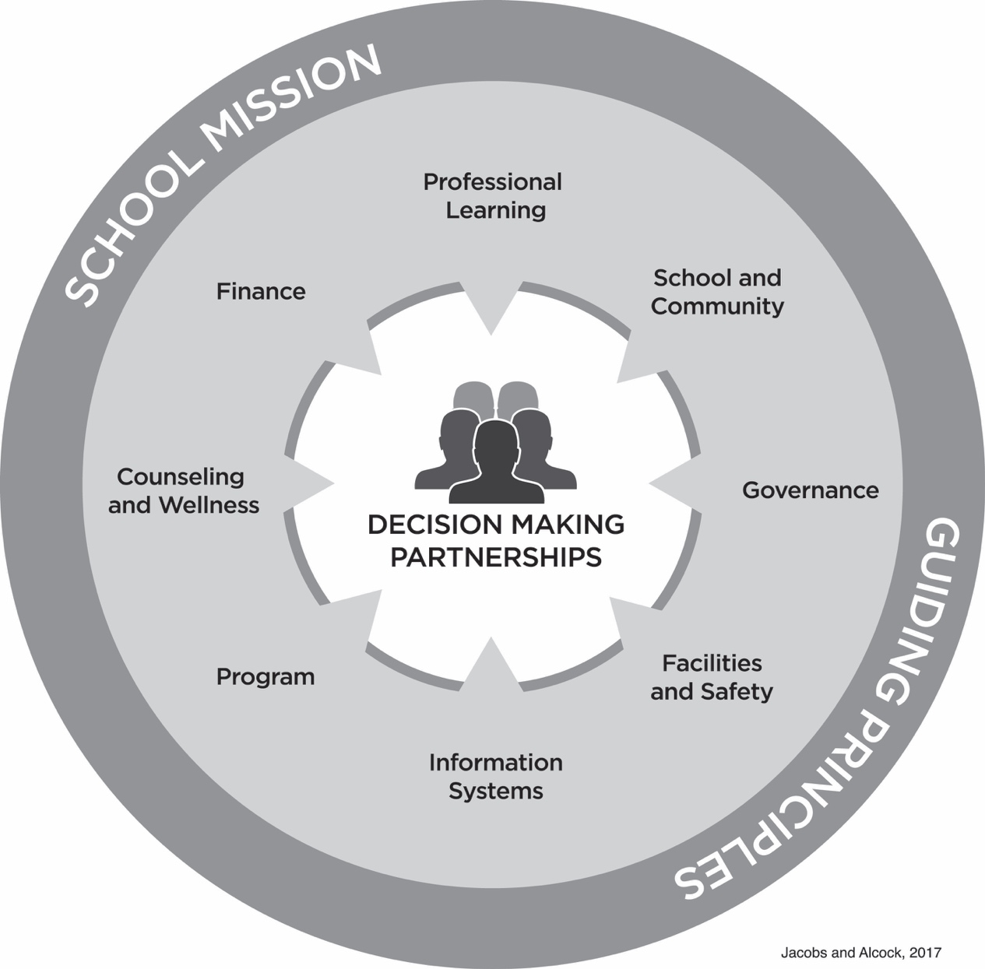

MISSION FORMATION TO LAUNCH
Action Steps and Decision Points | Evidence and Artifacts | Person(s) Responsible
- The mission is contemporary and future oriented, informing all decisions and programs in a documented, transparent manner and is archived by the school.
- The action plan or strategic plan is aligned to mission state- ment, including outlining speciﬁc assignments and responsibili- ties to partnership members.
- The organization has a clearly stated mission statement that is reviewed periodically and approved by the partnership.
- The partnership communicates its mission to all members, adults and students.

DOMAINS

SCHOOL AND COMMUNITY RELATIONS

Action Steps and Decision Points | Evidence and Artifacts | Person(s) Responsible
- The climate and culture of the school reﬂect the school’s mis- sion and philosophy.
- In keeping with its mission and philosophy, the school promotes an equitable, just, and inclusive community that inspires students to respect others and to develop and value global literacy.
- The school’s admissions and ﬁnancial assistance policies and practices are consistent with the school’s mission and philosophy and include efforts for diversity in the student body.
- The school employs person-to-person and digital media meth- ods of communicating with its stakeholders that are appropriate to the school’s mission, size, and means.
- There are clearly articulated and available channels by which members of all constituency groups (including partnership mem- bers, parents, students, alumni) can communicate and network in person and virtually in a meaningful way.
- The school strives to maintain good networking, ﬁeld experi- ences, and active relationships within its local community.
- The school consistently cultivates global networks, global curriculum, and active resources to support learner and teacher perspectives.
- The school strives to promote a commitment to environmental responsibility and sustainability for current and future generations.
- The school fully discloses its mission, policies, programs, and practices, including those related to networking and virtual space, to support safety, ethics, and efﬁciency.

INFORMATION SYSTEMS

Action Steps and Decision Points | Evidence and Artifacts | Person(s) Responsible
- The partnership has a contemporary program and plan that addresses communication, administration, and instruction.
- The partnership encourages Tier 1 individual networking where each professional connects to support personal instructional skills.
- The partnership maintains Tier 2 communication with an ofﬁcial blog, dashboard-supported data analysis system, and wiki structure for collaboration that provides useful information for all stakeholders.
Action Steps and Decision Points | Evidence and Artifacts | Person(s) Responsible
- The partnership maintains Tier 3 communication with ofﬁcial networking among schools and educational organizations on regional, national, and global levels where appropriate.
- A discipline policy and an anti-bullying policy are available both on-site and virtually.
- Policies and procedures are in place for addressing complaints by partnership members, parents, students, alumni.
- The school has policies and procedures that govern the reten- tion, maintenance, and use of personnel, ﬁnancial, corporate, legal, health and safety, and student records, including print and digital records. All records are encrypted and protected against catastrophic loss and are available only to authorized personnel.
- The partnership has clearly deﬁned policies and procedures that promote a climate of emotional and physical safety among students and among students and the partnership members. Dis- cipline practices shall be humane and mindful of every member.

PROFESSIONAL LEARNING

Action Steps and Decision Points | Evidence and Artifacts | Person(s) Responsible
- Partnership members undergo an orientation and ongoing pro- fessional learning with a mentor.
- A common website provides resources for all partnership mem- bers to access, attend, and share professional learning.
- Resources are available for organized collegial professional learning to be internally published and shared on a Tier 2 network.
- Resources are available for formal Tier 3 networks to initiate, build, and nurture global connections for professional learning.

PROGRAM DEVELOPMENT

Action Steps and Decision Points | Evidence and Artifacts | Person(s) Responsible
- The educational and extracurricular pro- grams stem from the partnership’s beliefs about teaching and learning, are consistent with the mission and philosophy of the partnership, and are reviewed regularly.
- Congruent with the partnership’s mission and philosophy, programs demonstrate consideration for intellectual, social, physical, aesthetic, and ethical education of students. The contemporary program encourages co-created learning experi- ences, joy in learning, and freedom of inquiry; respects diversity of viewpoints; and promotes deep thinking.
- The partnership’s curriculum, available both online and in print, is informed by its mission and philosophy. The curriculum wrestles with modern issues, problems, and possibilities. It is also stored in an analyzable database for pro-
cessing as curriculum data by the partnership to make informed decisions about program devel- opment using the curriculum-mapping process.
- Consistent with its mission and philosophy, the partnership’s program has sufﬁcient range for the contemporary needs, learning styles, developmental needs, and cultural and linguis- tic backgrounds of the students enrolled in the school system.
- The partnership has a clear process for supporting personalized learning experiences, reporting individual student progress, and shar- ing with parents or guardians on a periodic basis.
Action Steps and Decision Points | Evidence and Artifacts | Person(s) Responsible
- The partnership provides adequate resources (e.g., case studies, Tier 3 networks), and contemporary literacy sources that support and enrich the contemporary academic program.
- The partnership demonstrates responsible and ongoing understanding of current educational research and best practices consistent with its mission.
- The partnership has in place a procedure for follow-up on graduates’ success and uses result- ing data to assess its goals and programs.
- The partnership provides evidence of a thoughtful process, respectful of its mission, for the collection and use in partnership decision making of data (internal and external) about student learning, for both current and past students.
- The partnership’s online education and dis- tance education are congruent with its mission and philosophy.

WELLNESS

Action Steps and Decision Points | Evidence and Artifacts | Person(s) Responsible
- The partnership provides guidance, appropriate placement, advisory, and counseling services that are consistent with the part- nership’s mission and philosophy and educational program.
- The partnership provides appropriate health services for stu- dents and employees that are administered and carried out by personnel who have appropriate training and experience.
- The partnership meets all legal requirements regarding the physical and mental health services that it offers.
- The partnership follows relevant state standards for maintaining health information on students and appropriate conﬁdentiality guidelines when sharing information with partnership staff.
- If food services are provided, facilities and staff for food ser- vices meet applicable health and safety standards.

FACILITIES AND SAFETY
Action Steps and Decision Points | Evidence and Artifacts | Person(s) Responsible
- The school’s physical and virtual facilities and equipment are adequate to support its contemporary program.
- The physical and virtual facilities and equipment are ade- quately maintained, and a plan is in place for their long-term protection and upgrade.
- The school maintains its facilities and equipment so as to meet applicable health, ﬁre, safety, security, and sanitary standards, and has current documentation on ﬁle conﬁrming the safety standards.
- Preventative and emergency health, safety, and security procedures are clear and well documented, and include a crisis management plan for both on- and off-campus activities, virtual events, and external and internal threats.
- The school maintains a commitment to designing and maintain- ing a contemporary learning environment that is safe and efﬁcient, both physically and virtually, for all learners.

FINANCE

Action Steps and Decision Points | Evidence and Artifacts | Person(s) Responsible
- The school has sufﬁcient resources to maintain its program and meet the needs of the partnership members and student learners.
- The school has appropriate policies and procedures for manag- ing its ﬁnancial resources, including the following:
  - An accounting system that allows for timely preparation of an income statement and a balance sheet, covering all school revenues, expenses, and funds.
  - A budget-making process.
  - A ﬁnancial plan including historical and prospective data showing revenues, expenses, and fund balances.
  - A professional annual audit.
Action Steps and Decision Points | Evidence and Artifacts | Person(s) Responsible
- The ﬁnancial responsibilities of the parents and guardians are stated and published virtually (if applicable).
- The partnership ensures that the school has adequate provision for risk assessment, mitigation, and management, including the transfer of liability, property, and casualty risk through appropriate insurance.
- Controls are in place, including appropriate segregation of duties, for managing the funds of each organization operating under the umbrella of the school.
- The school has a development and advancement program con- gruent with its mission and philosophy and that can be reasonably anticipated to meet the current and future needs of the learners.

GOVERNANCE

Action Steps and Decision Points | Evidence and Artifacts | Person(s) Responsible
- The partnership is organized in a manner enabling it to carry out the mission and philosophy of the school.
- Partnership members annually receive written information regarding their responsibilities, compensation, beneﬁts, and terms of employment, all of which are administered fairly.
- The school has a clearly deﬁned and well- administered pro- gram of evaluation for partnership members.
- The school provides ongoing opportunities for professional learning.
- Partnership members are sufﬁcient in number to accomplish the work for which they are responsible.
- Partnership members verify that all partnership members are qualiﬁed for their positions and responsibilities, and are commit- ted to the mission and philosophy of the school.
- The partnership assigns all members to roles for faculty, admin- istration, and staff at appropriate intervals.
- The partnership conducts comprehensive background checks for all employees before the ﬁrst day of employment.
- The partnership reviews and maintains bylaws and keeps min- utes of meetings that conform to legal requirements.
- The partnership develops and regularly reviews partnership policies in a policy manual.
- The partnership operates in compliance with applicable laws and regulations.
- The partnership has sole ﬁduciary responsibility for the school and ensures that adequate ﬁnancial resources and facilities are provided for the institution.
- The partnership has appropriate policies to support the cre- ation, review, and approval of an annual operating and capital budget, as well as short- and long-range ﬁnancial plans.
- The partnership engages in regular strategic planning and docu- ments in writing the school’s strategic plan.
Action Steps and Decision Points | Evidence and Artifacts | Person(s) Responsible
- The partnership has an effective process to identify, cultivate, and select new members.
- The partnership ensures stability in transitions of partnership members and provides transition planning.
- There is orientation for partnership members and ongoing pro- fessional learning.
- The partnership has a regular, clearly deﬁned, and well-ad- ministered program of evaluation for itself as an entity and for individual partnership members.
- The partnership reviews annually and signs individually a con- ﬂict-of-interest and conﬁdentiality statement.

